
Company
Logotype

Cone Beam Computed Tomography- Report



Porur Dental X-rays & CBCT

Patient Name : Mrs. Kalpana | Date of Report : 20.09.2025
Age/ Gender : 29 years/ Female | Region of Interest : CBCT Full Skull
Referring doctor: Dr. S.M.M. Moulvi | Indication : Facial Asymmetry
Clinical Notes: Nil
PATIENT INFORMATION

CBCT- Full Skull provided
CBCT – IMAGE DETAILS

RADIOGRAPHIC INTERPRETATION

- Complete loss of crown and root structure in relation to 18.
- The long axis of the tooth 48 is present with slight disto-angular tilt when compared to the adjacent tooth 47, with the disto-coronal portion of 48 present withing the level of alveolar bone. Distance between the apical region of 48 and inferior alveolar nerve canal is 0.7mm (the inferior alveolar canal is present on the buccal aspect of the tooth 48).
- The alveolar ridge in relation to the maxillary and mandibular alveolar ridge is present with normal trabecular pattern.
- Right nasal passage obliteration is present.

RADIOGRAPHIC IMPRESSION

- Impacted tooth: 48
- Right nasal obliteration.

Kindly correlate with clinical findings


IMAGES FOR REFERENCE

RECONSTRUCTED PANORAMIC VIEW

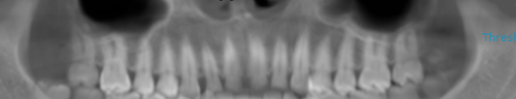
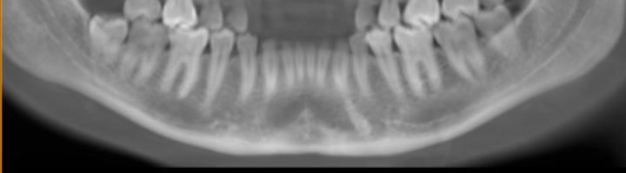

3-DIMENSIONAL VIEW

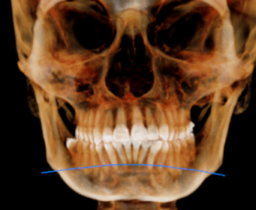

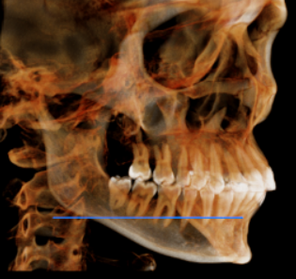
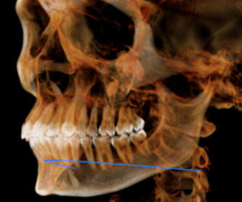

48 REGION- SAGITTAL SECTIONAL VIEW | 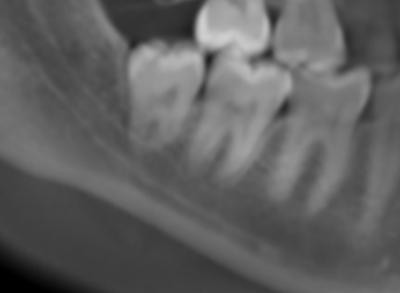
48 REGION- CROSS SECTIONAL VIEW | 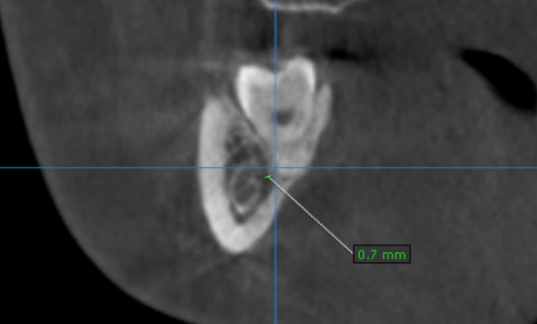  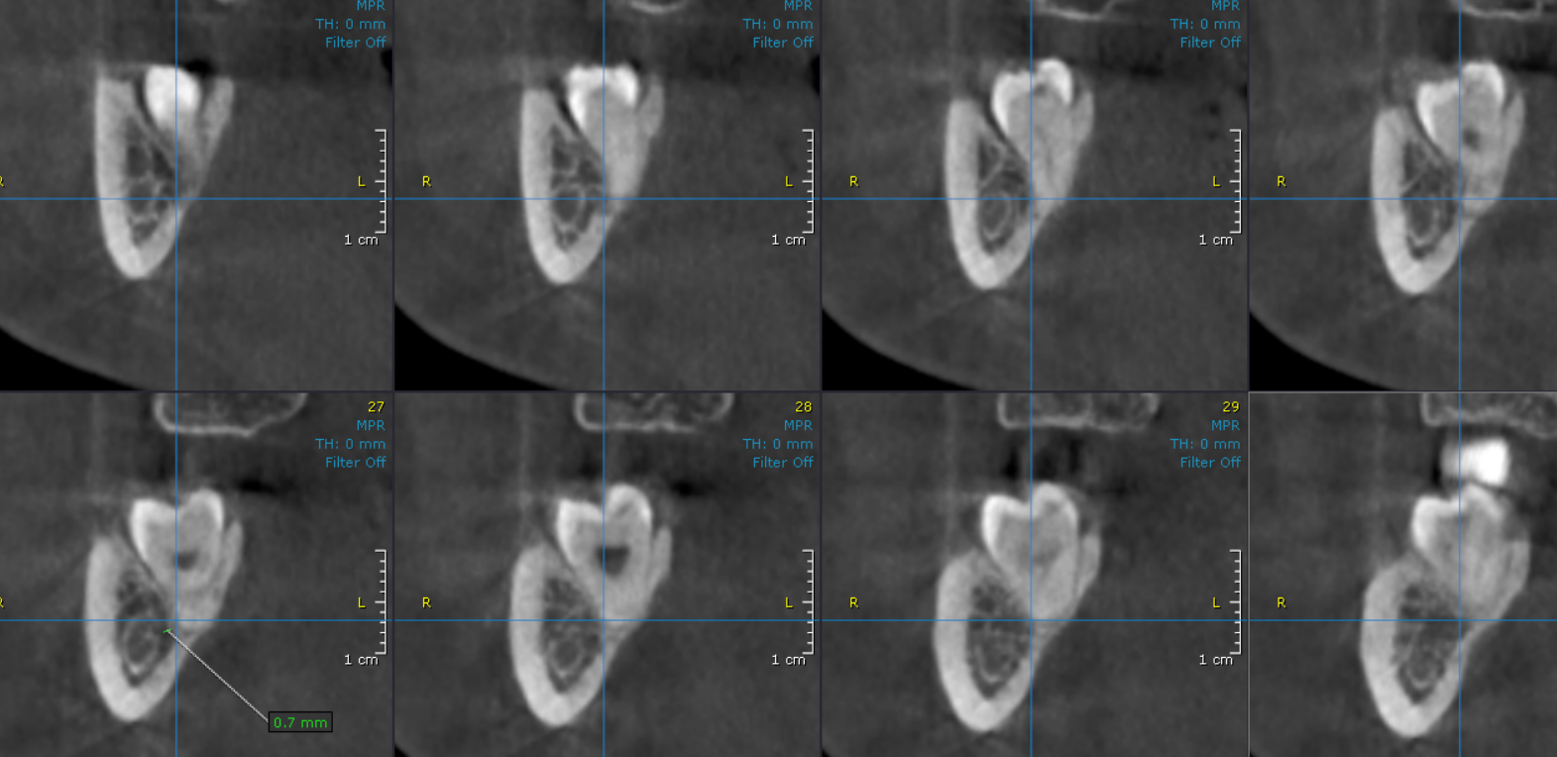
Nasal obliteration of right side | 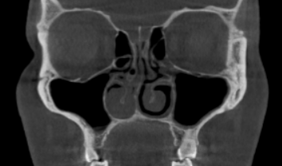

**** End of report ****

